§Web Programming UFCFB3-30-1

**phpMyAdmin Guide**

In this guide I am using XAMPP for OS X 5.6.3-0. A different version of xampp may have slightly different user interface but don’t worry they all do the same thing.

**Pre-requisite:** apache and mysql services are running in xampp.

This guide covers:

1. **How to load phpMyAdmin?**
2. **How to create a Database?**
3. **How to select/load a Database?**
4. **How to create a Table?**
5. **How to insert record in a Table?**
6. **How to see records of a Table?**
7. **How to edit a record in a Table?**
8. **How to delete a record in a Table?**
9. **How to execute an SQL statement?**
10. **How to alter a Table Structure?**
11. **How to export a Table (structure and data)?**
12. **How to import SQL statements?**
13. **How to get back to main screen?**

**1. How to load phpMyAdmin?**

* Type localhost in a web browser address bar
* Click on **phpMyAdmin** under Tools (left navigation bar) – see Figure 1.

**Note:** Default user is ‘root’ without any password. You can always change password – check Security link (left navigation bar)

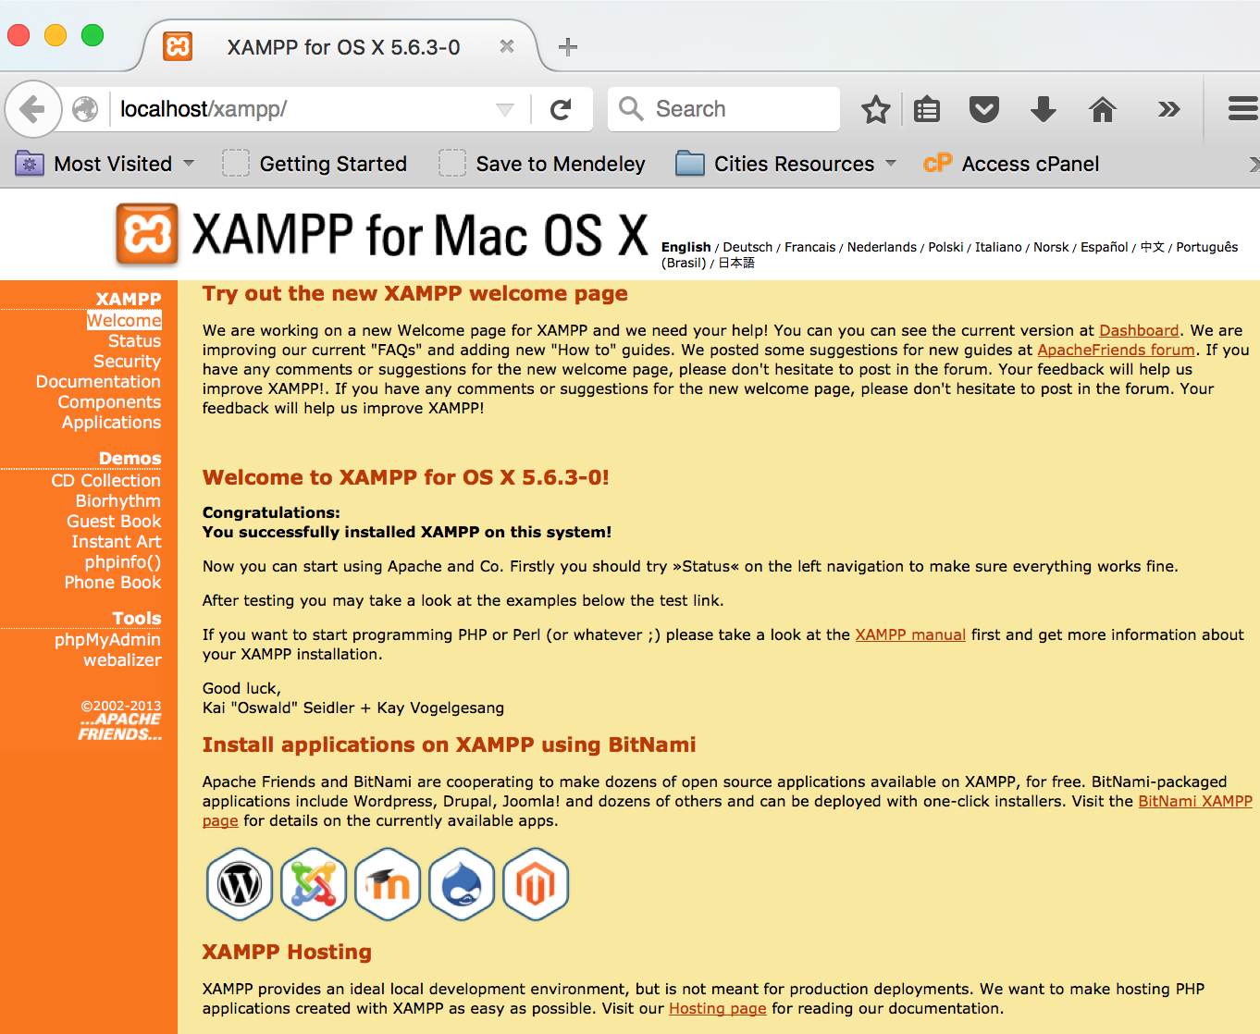

Figure 1:

If your database is password protected then you will have to enter user name and password – see Figure 2.

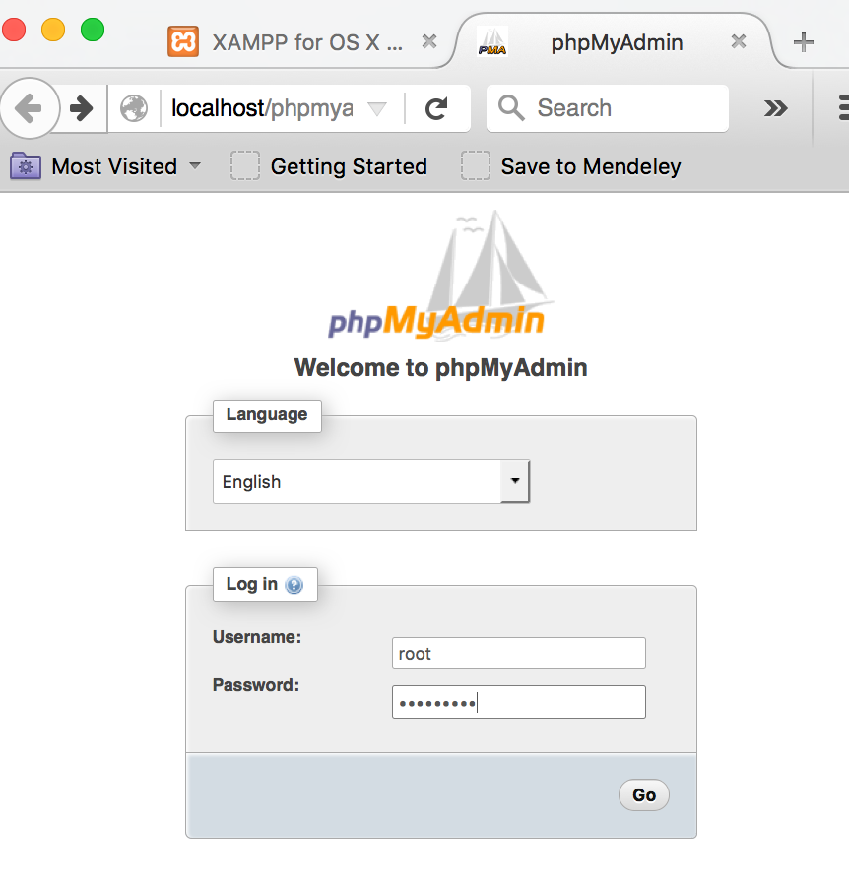

Figure 2:

Once you login you’ll see something similar user interface as shown in Figure 3. Leftside navigation bar shows all current databases in mysql. Centre top shows different tabs: Databases, SQL, Status, Users, Export, Import, Settings. Here we’ll use Databases to create databases, SQL to type SQL queries/statements, Export to dump SQL data (with SQL statements), Import to load data/SQL statements from another source.

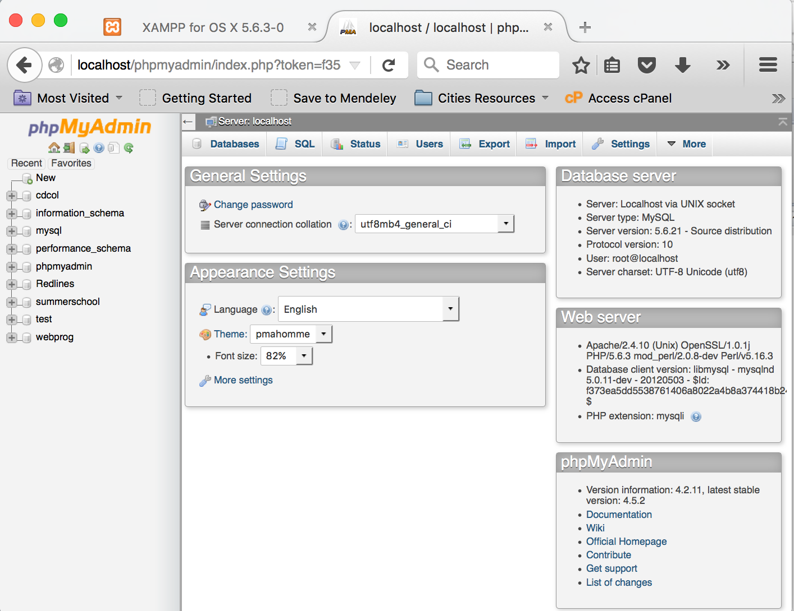

Figure 3:

**2. How to create a Database?**

Click on the Databases Tab. Type name of database you want to create (e.g. webdemo) in Create Database field and press Create (Figure 4).

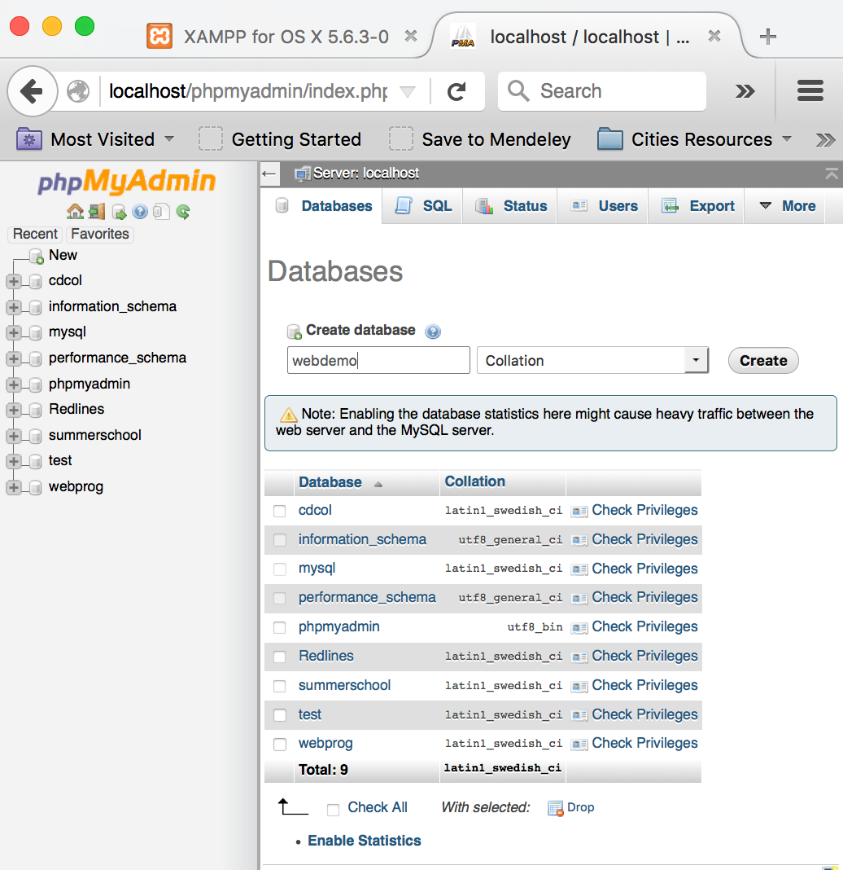

Figure 4:

This will create a new database e.g. webdemo and it will appear in the list of databases in left bar (Figure 5).

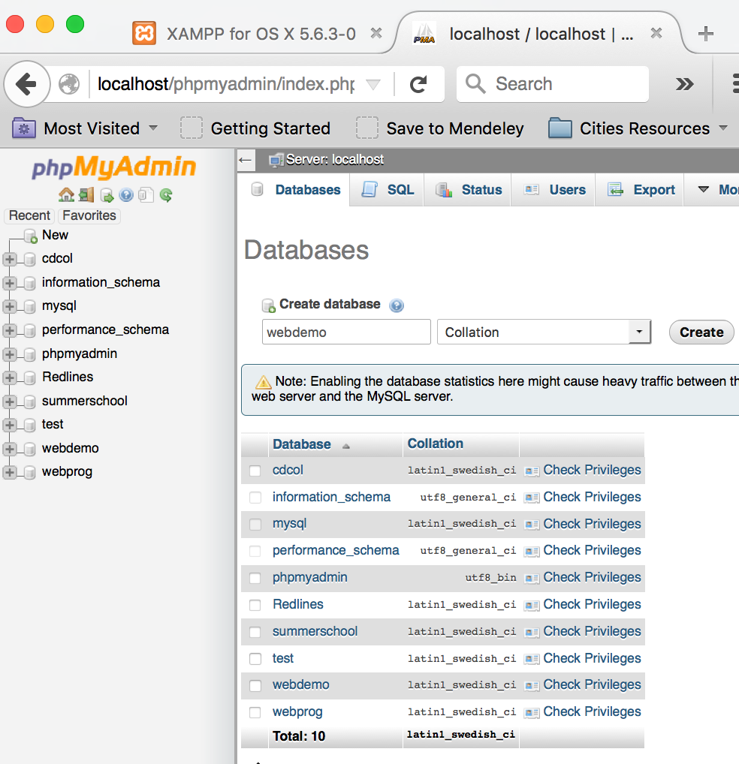

Figure 5:

**3. How to select/load a Database?**

You can select a database by clicking on the database name in left menu. E.g. if I want to load webprog then I’ll click on webprog and it will look something like – see figure 6. It will show all tables or stored procedures (if any) in that database. Similarly, if you click on webdemo then it will look something like – see figure 7. Since it is just created there is no table in webdemo.

**Note:** Notice new tabs: Structure, SQL, Search, Query, Export, Import, etc…

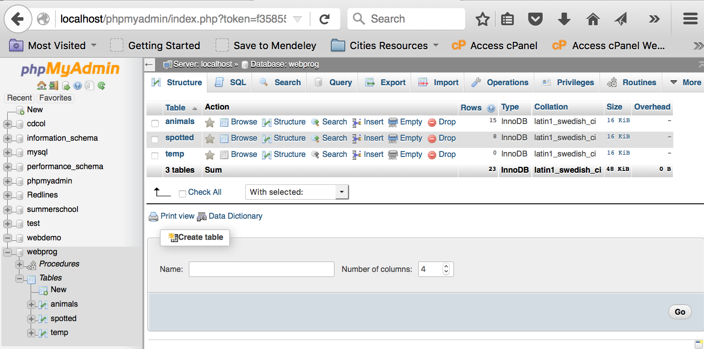

Figure 6:

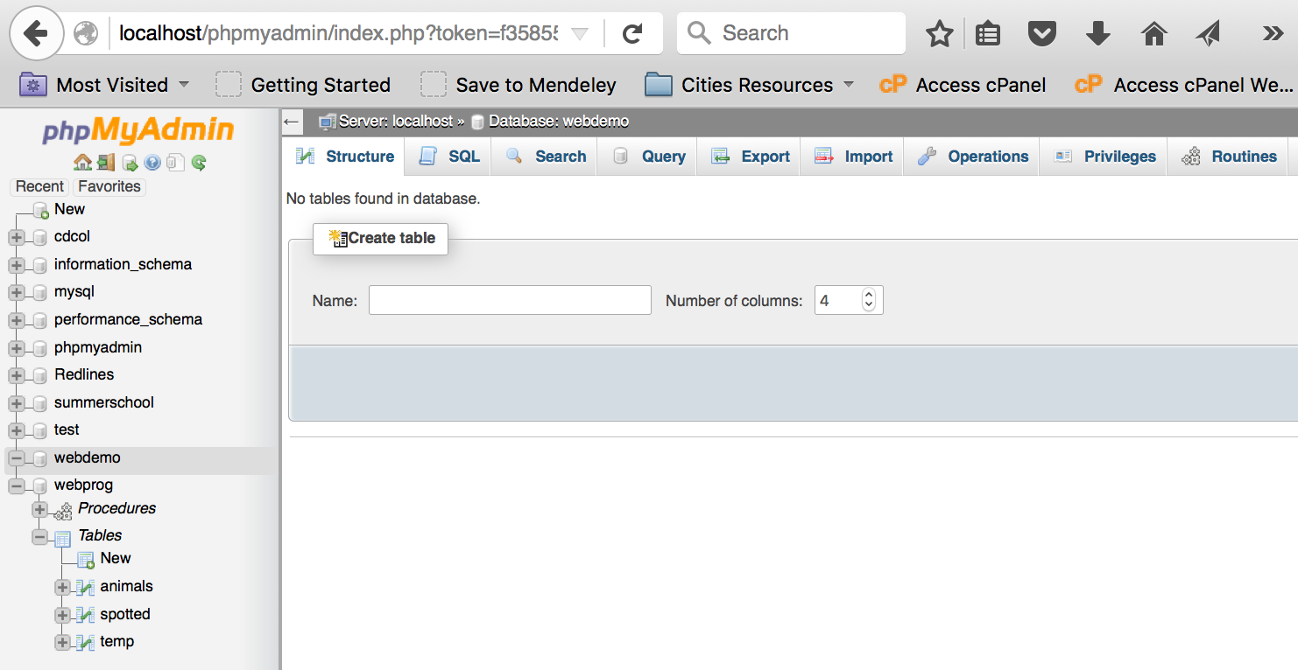

Figure 7:

**4. How to create a Table?**

Above Figure 7 shows user interface to create a table. You need to type table name (without spaces) and number of attributes (fields or columns) your table will store. For example, if I create a table name Students with three attributes – studentid, name and email where studentid is primary key (i.e. unique), then see Figure 8, Figure 9 and Figure 10.

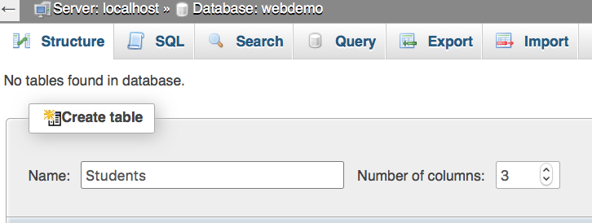

After you press Go – then see Figure 8.

Figure 8:

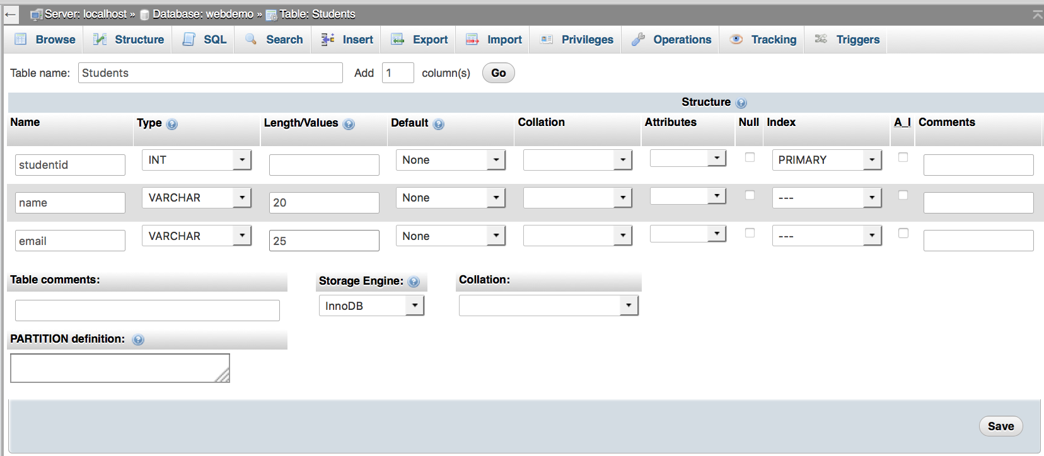

Figure 9:

After you press save - then see Figure 10. Also see actions you can perform on Students table.

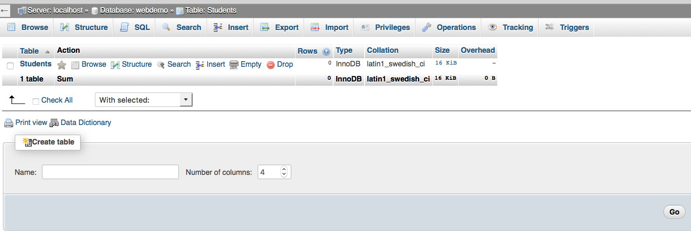

Figure 10:

**5. How to insert record in a Table?**

See Figure 11. Select table from left side and click on the Insert tab. Insert data in Values cells for each table field. Press Go to insert records.

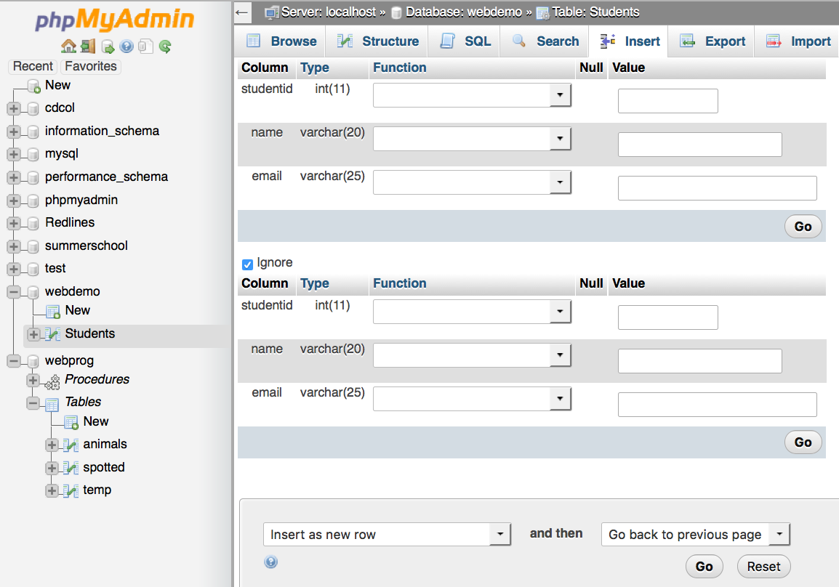

Figure 11:

When you’ll press Go button you’ll be able to see SQL statement – see Figure 12.

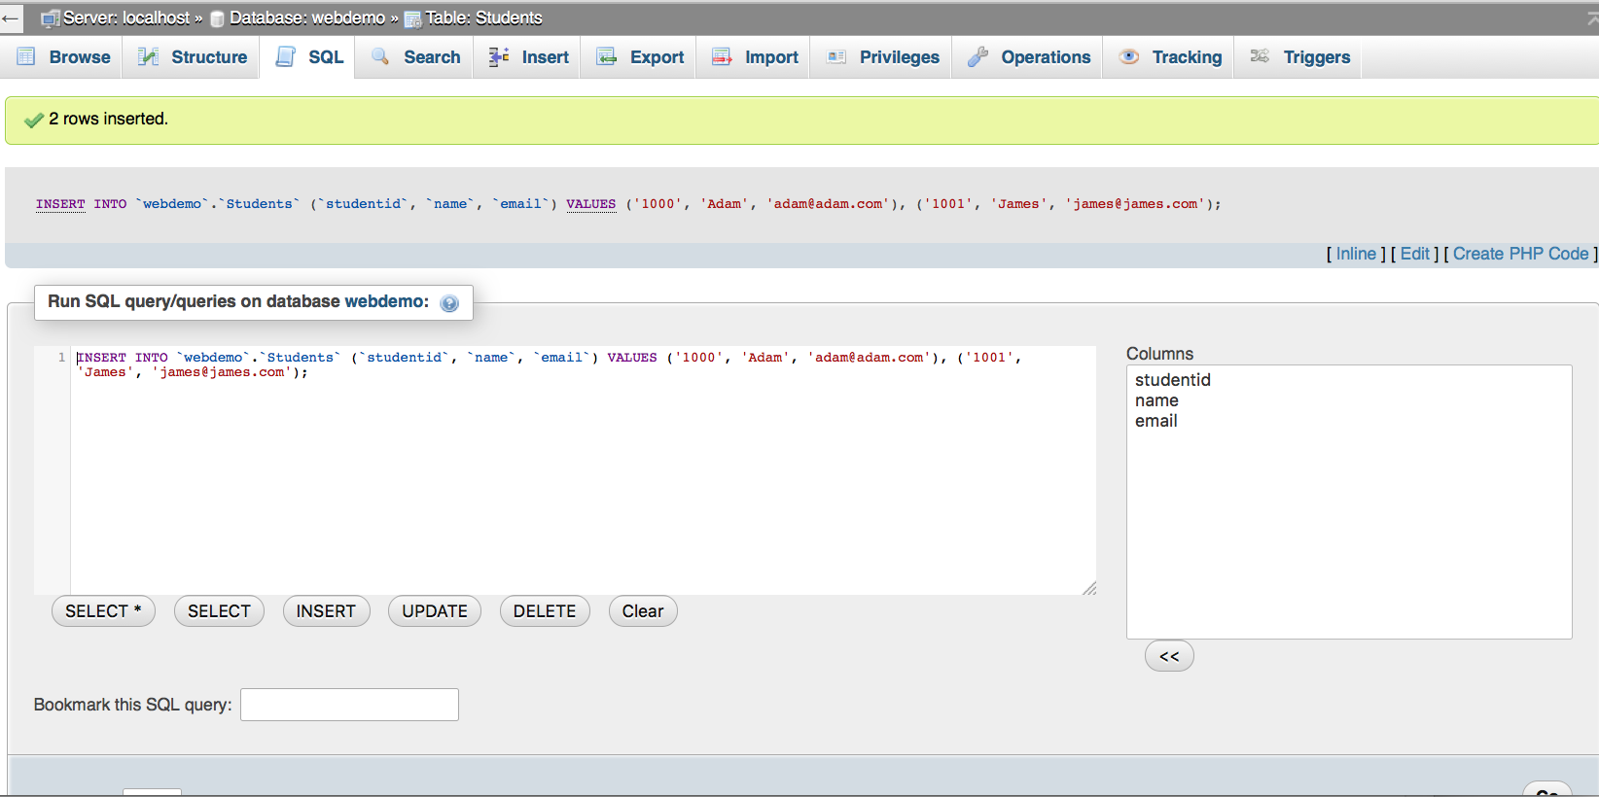

Figure 12:

**6. How to see records of a Table?**

Click on the table name and you should be able to see all records (i.e. data) in that table. Also you should be able to edit (see Edit button) or delete (see Delete button) any record. See Figure 13:

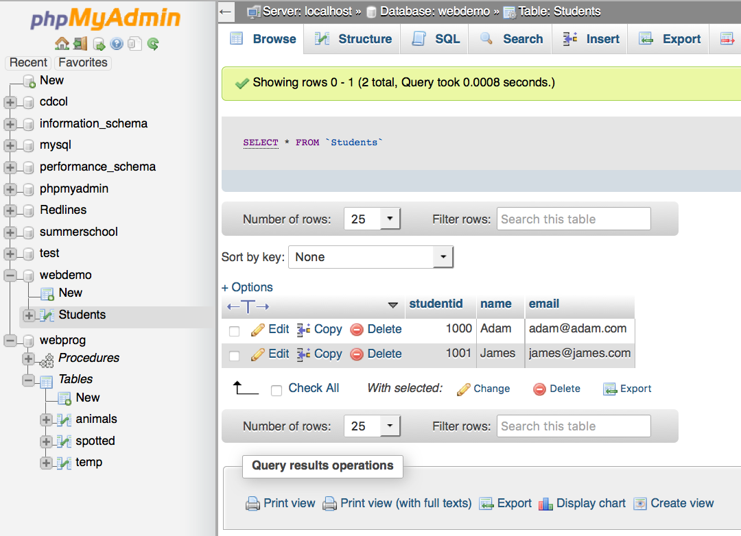

Figure 13:

**7. How to edit a record in a Table?**

Click on Edit for record which you want to edit (see Figure 13). Edit data in table fields - see Figure 14. When Go button is pressed then see the result - Figure 15:

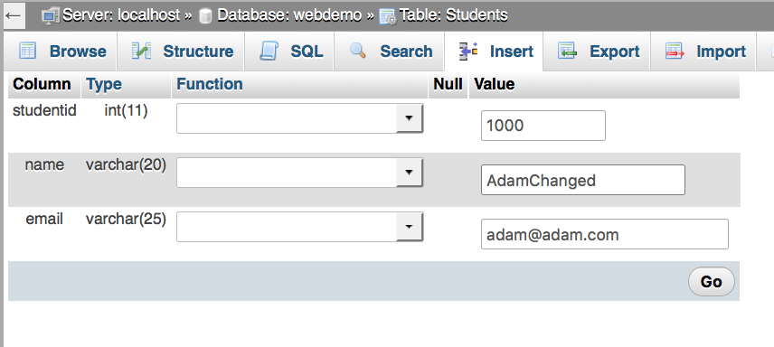

Figure 14:

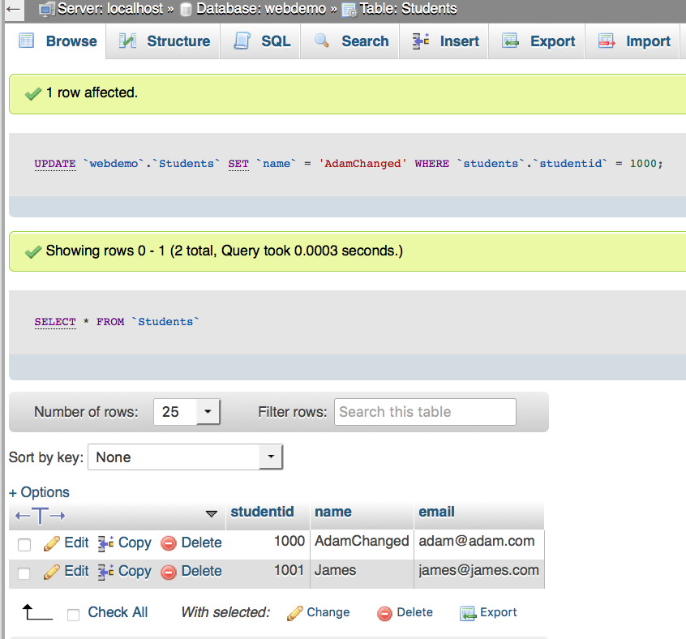

Figure 15:

**8. How to delete a record in a Table?**

Click on Delete in a record row (Figure 15) and it will delete the record – see Figure 16. Figure 17 will show updated table where that deleted record won’t appear.

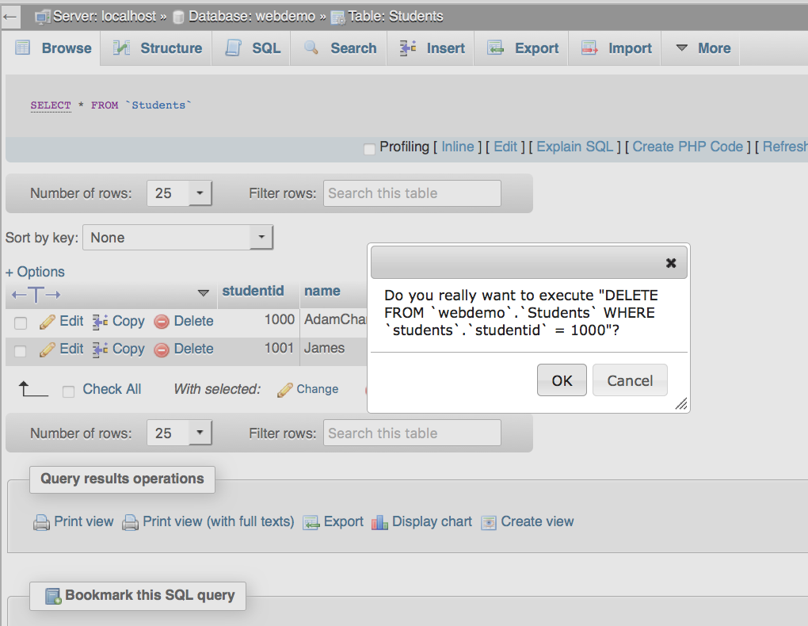

Figure 16:

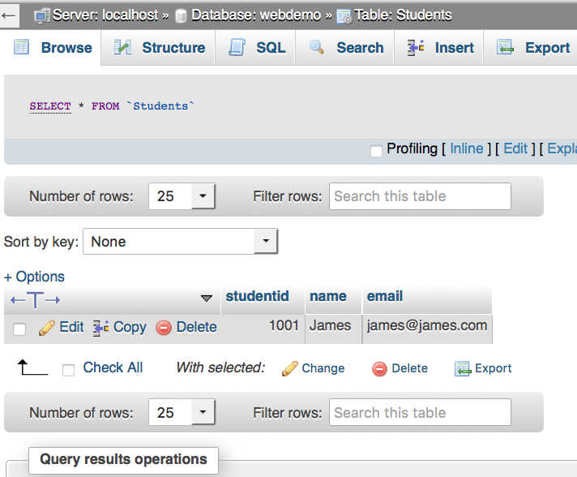

Figure 17:

**9. How to execute an SQL statement?**

Click on SQL tab and type your SQL statement and press Go – see Figure 18.

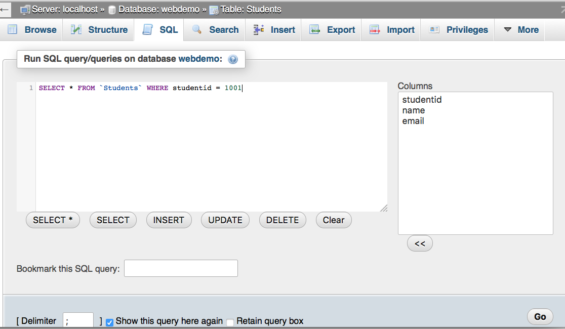

Figure 18:

Figure 19 will show the outcome or result of SQL query.

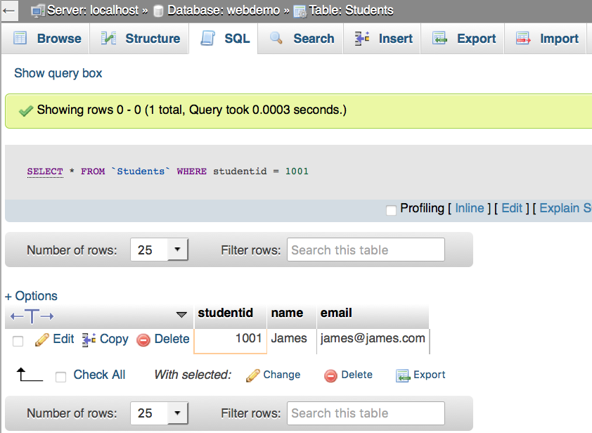

Figure 19:

**10. How to alter a Table Structure?**

Click on the Structure tab and from here you should be able to alter table structure e.g. add a new column/field, change data type for a column etc. – See Figure 20:

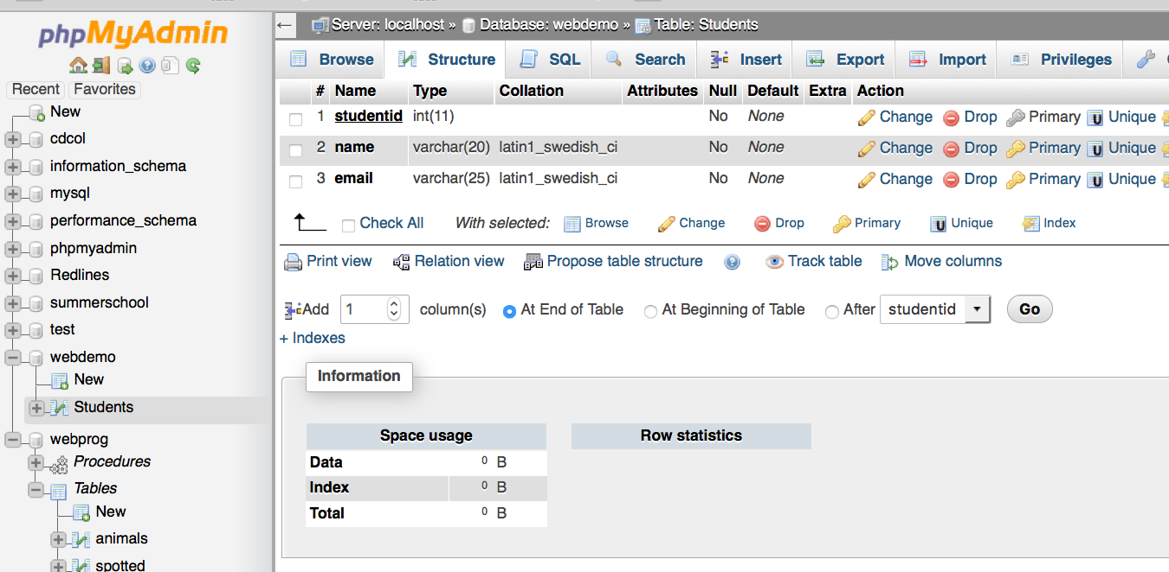

Figure 20:

**11. How to export a Table (structure and data)?**

Click on Export tab to export SQL dump (table structure and data) Figure 21. It will save an SQL file which will have all sql statements to create same table and records – see Figures 22 and 23. This will help you to take backup of your database. You can export your database and then import on another mysql server/machine.

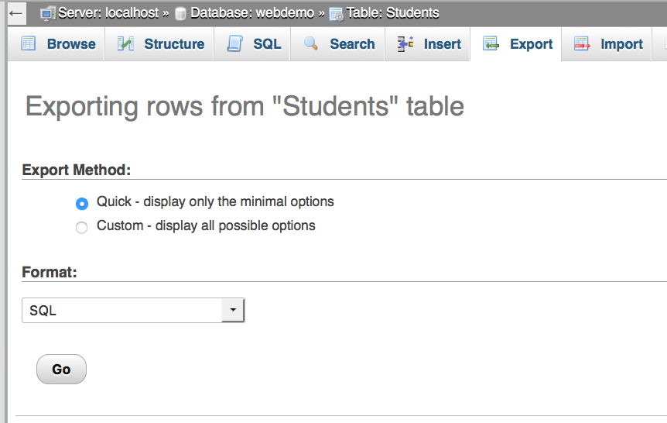

Figure 21:

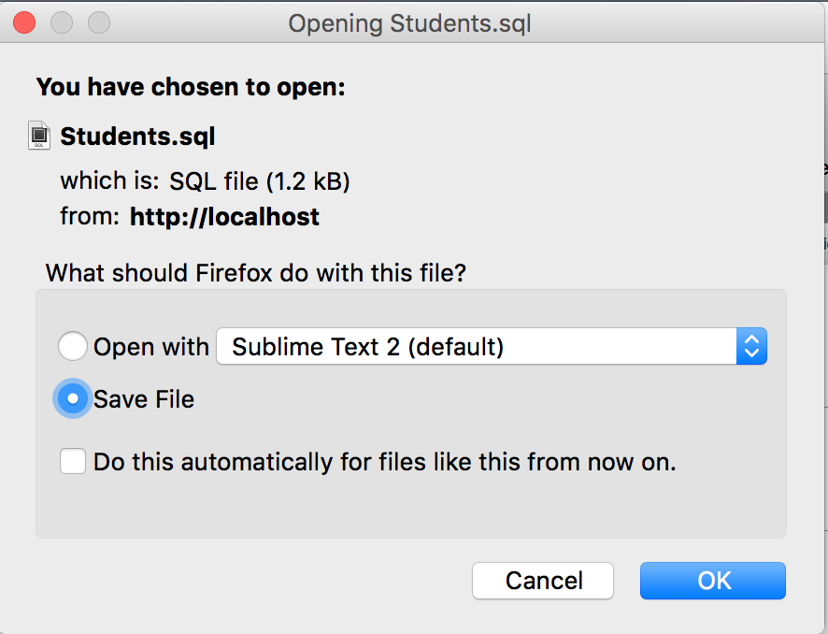

Figure 22:

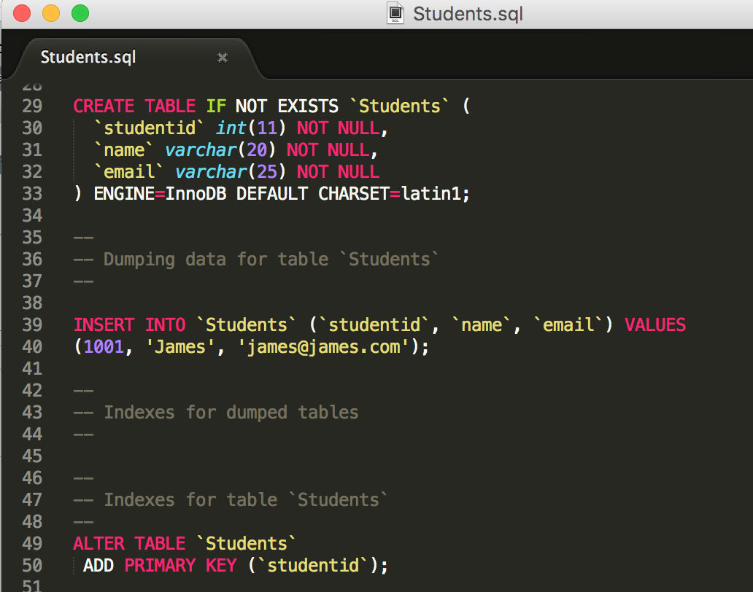

Figure 23:

**12. How to import SQL statements?**

You can write multiple SQL statements in one file and save it with extension .sql. For example, you can write all INSERT INTO statements for Students table and then import it in Students table using phpMyAdmin import feature. In phpMyAdmin, you can click on import tab to load .sql file – see Figure 24.

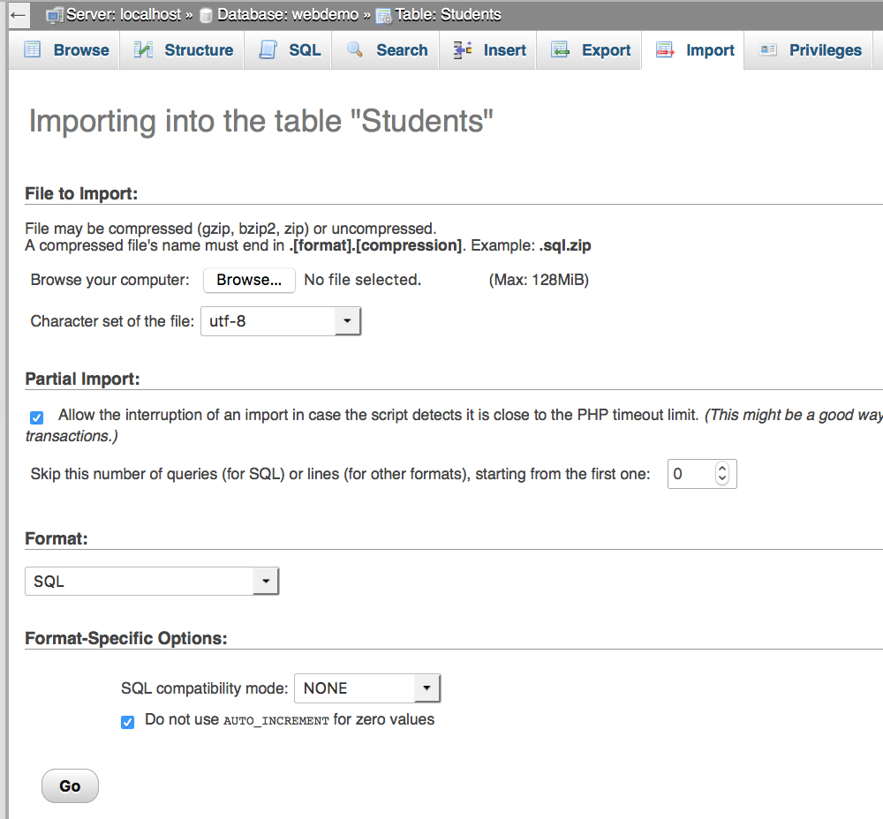

Figure 24:

**13. How to get back to main screen?**

Use toolbar from top-left of phpMyAdmin area to get to home screen – see Figure 25.

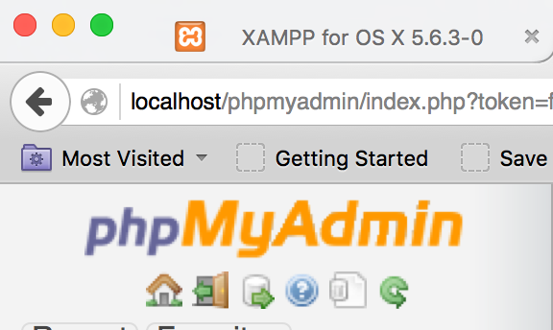

Figure 25: